TERMS OF REFERENCE
KIRIBATI OUTER ISLANDS TRANSPORT INFRASTRUCTURE INVESTMENT PROJECT (KOITIIP)
OUTER ISLANDS IMPLEMENTATION UNIT (OIIU)

Position: OIIU CHIEF TECHNICAL ADVISOR (International)

Duty Station: Full-time in OIIU Project Management Unit, Ministry of Finance & Economic Development

Start date: As soon as possible

Duration: Three year period with possible 1 year extension (initial contract to be offered up to June 2020 to coincide with project preparatory funding)

Reporting to: [OIIU Project Manager] Secretary, Ministry of Finance and Economic Development

1. BACKGROUND
- The Republic of Kiribati is one of the most remote and geographically dispersed countries in the world. It comprises three island groups, namely; the Gilbert Islands Group, Phoenix Islands Group, and Line Islands Group (refer to Annex 2). The country’s inhabited islands include 33 low lying atolls and one raised limestone island. The islands are scattered over an ocean area of 3.5 million km² of the central and western Pacific with approximately 3,200 km separating the eastern and western-most outer islands. The atolls are generally less than 2 km wide and not more than 6 m above sea level. Kiribati is constrained by geographic isolation, high transport and shipping costs and a low population base. The nature of the relative infertility of its coral islands prohibits agricultural production on a large scale.
- Twenty-one of the islands are inhabited by the national population of around 114,000, with the majority residing on the Gilberts group of islands. The outer-islands population ranges from a few thousand to less than a hundred across the different island chains, with approximately 51% of the country’s population living in the capital on South Tarawa (within the Gilberts). Its population is majority rural and growing, with a fertility rate of 3.7 children and life expectancy at 66.1 years (2015). South Tarawa is a magnet for internal migration from the outer islands as it provides opportunities for employment and consumption, as well as access to higher education and specialist social services not available elsewhere in Kiribati.
- Kiribati’s low-lying atolls are at the forefront of climate change. Kiribati is highly exposed to the effects of sea level rise, storm surge, coastal erosion and saltwater intrusion. Access to fresh water is particularly challenging, as saltwater intrusion and drought increasingly affects Kiribati’s very limited groundwater supplies. Between 2005 and 2015, 94% of household in Kiribati report having been impacted by environmental hazards. In this same period, 81% report having been impacted by rising sea levels. Saltwater intrusion impacted just under half of all households. All of the other hazards (storm surges, floods, cyclones and droughts) were reported more frequently in the outer islands than in South Tarawa.

2. Detailed Project Components and Activities
- The following project components and activities are being considered as part of the US $ 42 million KOITIIP project.
Component 1: Safe Inter-Island Navigation. This component will finance hydrographic surveying (by Airborne Laser Bathymetry [ALB] and vessel-based Multi-Beam Echo Sounder [MBES] surveys) and maritime charts focusing on the four target islands to significantly improve the safety of navigation. In addition to hydrographic surveying services, the component will finance contractor management services, as well as seabed-mounted tide gauges and current meters in certain locations on each target outer island. The component is especially important as it is a precursor to, and will directly inform, the design of the maritime works in Sub-Components 2.1 and 2.2.

Component 2: Resilient Outer Island Access Infrastructure. Activities to be financed under this component include: (a) technical engineering studies, including climate resilience measures, and preparation of bidding documents for project related activities; (b) preparation of environmental and social safeguards instruments; (c) execution of civil works; (d) supervision of civil works; (e) maintenance of project assets; (f) third-party technical audits; and (g) third-party environmental, social, and security audits of the civil works. Activities will include on-the-job training of unskilled labor living in the project area in charge of carrying out project rehabilitation works and GoK routine maintenance, will promote the participation of women, and will include project related gender-based violence (GBV) prevention and mitigation measures.
  - Sub-Component 2.1 Improvement of Ships Safety Navigation (approximately US$2 million equivalent). This sub-component will provide assistance to design, to replace existing defective AtoNs, to fabricate and install new AtoNs, as well as technical assistance to establish a system of maintaining these assets, and preparation of environmental and social safeguards instruments. The locations of the new AtoNs will be informed by the hydrographic and charting outputs (Component 1).

  - Sub-Component 2.2 Rehabilitation of Island Access Infrastructure. Following completion of the hydrographic surveys, this sub-component will finance engineering studies, civil works, and preparation of environmental and social safeguards instruments, for a variety of maritime infrastructure improvements (including associated infrastructure), tailored to the needs of each island, as follows: (a) construction of jetty, passenger terminal and concrete ramp on Abaiang; and small-scale passenger terminal, and seawall upgrade works on Beru; (b) construction of small multipurpose maritime facilities on Nonouti and Tabiteuea South, including concrete boat ramp, shelter, and AtoN workshop and small equipment; and (c) accompanying consulting services to support delivery of the design, construction and maintenance activities of Sub-Component 2.2.(b), including engineering studies, capacity development of MISE staff, and quality assurance audits, as well as preparation of environmental and social safeguards instruments.

  - Sub-Component 2.3 Rehabilitation of Lagoon Crossings. This sub-component will finance: (a) rehabilitation works for existing causeways, including enabling works and related investments, to ensure accessibility on prioritized outer islands. The rehabilitation works will include climate resilient features such as the provision of durable wearing course, proper drainage, and erosion control. The maintenance of the causeways will be secured during the project period, by providing technical assistance and training for developing and implementing causeways maintenance programs, and by promoting the participation of women on the maintenance teams; and (b) accompanying consulting services to support detailed design and delivery of this sub-component, including technical assistance to support site investigations, engineering studies, design, construction, and maintenance of the causeways, supervision of works, quality assurance audits, capacity development of MISE staff, and preparation of environmental and social safeguards instruments.

Component 3: Strengthening the Enabling Environment. This component will strengthen MICTTD and MISE’s institutional and regulatory functions for transport sector asset management, systematically increasing the sustainability of the climate resilient transport sector investments. The component will also provide project management and operational support to KOITIIP and KFSU, as well as promote the participation of women and will include project related gender-based violence mitigation measures.

- Sub-Component 3.1 Institutional Strengthening. This subcomponent will provide technical assistance to support the capacity development for the two implementing agencies MICTTD and MISE.

- Sub-Component 3.2: Operational Support for the Outer Islands Implementation Unit (OIIU). This subcomponent will finance project management and operational costs associated with the implementation of the proposed project. The sub-component will support gender informed activities, including citizen engagement, outreach activities, and developing employment networks designed to increase women’s participation and prevent GBV. Beneficiaries’ participation and feedback during project preparation and implementation will be facilitated through citizen engagement processes.

- Sub-Component 3.3: Operational Support for the Kiribati Fiduciary Services Unit (KFSU) This subcomponent will strengthen the capacity of the existing KFSU, to provide implementation support to this Project and other IDA/IBRD financed or co-financed projects. It will finance project management and operational costs associated with the implementation of the proposed project.

Component 4: Contingent Emergency Response. Following an eligible crisis or emergency, the Recipient may request the Association to re-allocate project funds to support emergency response and reconstruction. This component would draw from the uncommitted resources under the project from other project components to cover emergency response.

3. Proposed project implementation timeline. The project is proposed to be implemented over a 6-year timeline due to the interdependence of planned project activities. The rehabilitation of the maritime island access infrastructure under Sub-Component 2.2 would start only after the completion of the hydrographic surveys. Works for the construction/rehabilitation of a range of maritime infrastructure covering jetties, barges, small scale dredging, and related investments are expected to occur during years 4-6 of the project, following the one-year design and procurement phase.
- The day-to-day implementation of Outer Islands Implementation Unit (OIIU) will be led by the Project Manager with full support from the Chief Technical Advisor, Project Steering Committee (PSC), Technical Task Force (TF) and Kiribati Fiduciary Services Unit (KFSU). These institutions form the Kiribati Outer Islands Transport Infrastructure Investment Project (KOITIIP), shown in Annex 1. Additionally, MISE will establish a MISE implementation unit that will lead the development of designs and construction supervision tasks. Construction activities are expected to use a combination of small domestic contractors and MISE Force Account workers.
- The Table below shows the OIIU, KFSU and PSC staffing:
Outer Islands Implementation Unit (OIIU) | Kiribati Fiduciary Services Unit (KFSU) | Project Steering Committee (PSC)
Project Manager  Chief Technical Advisor  M&E Specialist;  Community Liason  Other staff as needed (Procurement Manager;  Safeguards Expert; Gender Specialist etc) | Procurement Expert  Finance Manager  Safeguards Expert  Monitoring and Evaluation Expert | Ministers and/or Secretaries from:  Ministry of Finance and Economic Development (MFED)  Ministry of Information, Communication, Transport and Tourism Development (MICTTD)  Ministry of Infrastructure and Sustainable Energy (MISE)  Ministry of Internal Affairs (MIA) and Island Councils  Ministry of Women, Youth, Sports and Social Affairs (MWYSSA)  Ministry of Environment, Lands and Agricultural Development (MELAD)

4. OBJECTIVE
The main objective of this OIIU Chief Technical Adviser consultancy is to ensure that the KOITIIP is implemented successfully, in accordance with IDA and ADB standards and procedures, the Grant Agreement, Credit Agreement, Project Agreement, and other approved project documentation.

5. Scope of services

The primary role of the CTA is to provide technical support and mentoring of the OIIU Project Manager (PM) to be able to competently deliver all functions. This will be through a combination of effectively full-time support for the first one year, followed by part time support for a further two years.
The detailed scope of services to be provided (in each case this involves a combination of mentoring the PM to undertake the activity or undertaking the activity directly) is in accordance with the following activities:-
- Project Management, Evaluation and Monitoring. Provides technical advice and support to the Project Manager for the following:
  - Planning for the implementation of KOITIIP with the DTTF, PSC, KFSU and other parties in country as required, and ensure that the Project is implemented according to plan and any variances reported in a timely manner;
  - Coordination of inputs between the MFED, MICTTD, MISE, MIA, KFSU and other stakeholders as required to support Project implementation;
  - Support and participation in WB and ADB missions, including following up on agreed action items, coordination of meetings, and liaison between MFED, MICTTD, MISE, ADB and WB as required to support Project implementation;
  - Design and develop a project management framework with clear outputs and outcomes, activities and timelines (including maintaining a project gantt chart updated at least monthly with progress against the agreed baseline program), quality assurance and control mechanisms, evaluation and monitoring procedures, possible risks with risk management plan, etc. and using relevant computer-based project standards in consultation with relevant stakeholders as per b) above;
  - Conduct day-to-day oversight of activities and budget in coordination with the grant, government budget and project agreements and to provide the TTF matters of concern that needs to be addressed;
  - Prepare quarterly and semi-annual project progress, project completion and financial reports for Project donors and the Executing Agency (EA) and Implementing Agencies (IA) and seek any support and guidance needed for the management, planning and controlling of the Project;
  - Identify and propose to EA eligible projects to be financed under subsequent tranches of the project with consultation with the TTF;
  - Review all OIIU correspondence.
- Project Implementation. Provides technical advice and support to the Project Manager for the following:
  - Provide overall management of the Projects,
  - Ensure that funds are used for the purposes intended with due consideration to the economy and efficiency and in line with the provisions stipulated in the relevant legal documents (e.g. WB financing agreement) ;
  - In consultation with MFED, represents the MFED as the Employer for all works contracts, and as the Client under the Contracts for Consulting Services. Manages and supervises the OIIU staff activities involved in the Projects implementation and ensures another technical staff involvement when necessary;
  - Designs, prepares and monitors operational procedures, policies and standards in line with applicable procedures and guidelines;
  - Oversees project implementation including conducting field visits to ensure timely completion of activities and outputs, high quality of works, cost-efficiency, and value for money in compliance with international standards and prepared designs;
  - Ensures that the amounts certified by the engineers are processed and paid to the contractors for works contracts within the time specified in the Contract with the approval of the IAs.
  - Certifies invoices submitted by the Project consultants and ensures that the invoices are processed and paid to the consultants within the time specified in the Contract in consultation with the IAs.
  - Oversees with the EA and IAs the duly implementation of the institutional strengthening and capacity building components including legal, financial and regulatory reforms;
  - Where appropriate, and in consultation with the KFSU, initiates claims against the contractors, on behalf of MFED and to formally inform the IA;
  - Reviews, comments and approves all outputs of the Project consultants including due diligence documents for detailed design, project progress reports, etc.;
  - Takes action against the Project consultants, where appropriate, to ensure that the consultants’ outputs are in accordance with their contracts, and to protect Government of Kiribati (GoK) interests with the copy of the information provided to the TTF;
  - Items i-k above extends to holding MISE delivered works and services to a similar standard to that of the private sector;
  - Ensures accurate Project completion and review and timely submits project activity reports and financial statements to EA and IA and other state authorities and Project donors as required in the agreements, to assess progress status in regard to objectives, targets and schedule;
  - Instigate and supervise an OIIU reporting and monitoring system.
- Procurement. Provides technical advice and support to the Project Manager for the following:
  - Manage all contracts throughout their procurement and implementation, with information provided by KFSU, MFED, MICTTD, MISE as appropriate;
  - In consultation with the KFSU, EA and IAs (and PSC if deemed necessary), form and head bid evaluation committees, review and approve recommendations for contract award;
  - In consultation with the KFSU, supervise the procurement planning and procurement implementation in compliance with the applicable procurement guidelines, including preparation and/or review of the bidding documents, evaluation reports and conducting contract negotiations with consultants/contractors;
  - In consultation with the KFSU, supervise the monitoring of the procurement plans, ensuring integrity of the entire procurement process;
  - Monitor performance of consultants/contractors and follow-up as necessary and report to IAs;
  - Deal with contract variation, claims or requests as necessary in consultation with the KFSU and IAs;
  - Approve Terms of Reference for various assignments under the Projects and submit to the Donors for review and no-objection in consultation with the KFSU and IAs;
  - Ensure that the OIIU establishes an appropriate project web site consistent with WB and ADB requirements (e.g. www.tvaip.com). Disclose relevant contractual information on the KOITIIP project website. The Project Manager will support the weekly input and verify that the information is up to date;
  - The project web site will also publish geo-tagged photos showing work progress. As a minimum at the start of each month — or after the completion of any major activity on the project — the Consultant shall ensure that sufficient geo tagged photos are uploaded for all elements of the project so as to provide an accurate, ongoing record of progress.
- Social and Environmental Safeguards. Provides technical advice and support to the Project Manager for the following:
  - Supervise the preparation of safeguards due diligences in compliance with applicable Safeguard Policy (LARF, LARP, EIA/IEE, ESMP, information, consultation, surveys, timely payment of compensation…);
  - Supervise and monitor safeguards documents implementation and check compliance with the applicable Safeguard policy, with particular attention to the resettlement plan and income and livelihood restoration plan of Affected people (AP);
  - Similarly, ensure that KOITIIP complies with Kiribati laws and regulations;
  - Ensure that requisite measures from the ESIA and ESMP are incorporated into the bid and contract documents;
  - Ensure that the ESMP is updated with respect to detailed designs and that contractors complete their Contractor ESMPs (CESMP) in the preconstruction phase;
  - In partnership with MISE and MICTTD, undertake monitoring of the implementation of the CESMPs, and based on this monitoring prepare corrective action plans;
  - Implement all mitigation and monitoring measures for various project phases specified as OIIU tasks in the ESMP and CESMP/s;
  - Work with MELAD to undertake any additional environmental assessment for KOITIIP sub-projects prior and submit to MELAD, WB and ADB for review and clearance;
  - Prepare quarterly or semi-annual safeguards monitoring reports for submission to MFED, WB, ADB and others as necessary;
  - Work with the OIIU environmental specialist to ensure that training and capacity building is provided to MISE and MICTTD staff (including management);
  - Similarly, for each contractor, ensure that OIIU environmental specialist provides training to engineers, operators and contractor management prior to the submission of the CESMP by the contractor;
  - During detailed design, notify MELAD, WB and ADB of any change in work areas or project design / components and provide all necessary information to facilitate preparation of any additional environmental assessment prior to project construction as required in the ESMP. This may necessitate new or supplementary environmental assessment;
  - Review the complaints registered in the project Grievance Redress Mechanism (GRM) and ensure that they are being dealt with in accordance with the resolution mechanism and that the data in the GRM are kept current and up to date.
  - Monitor the adherence of all project participants (contractors, consultants, etc.) to the requirements with regard to implementing the project Codes of Conduct for Gender Based Violence. Ensure that all OIIU staff have taken the necessary training and are adhering to the agreed standards;
  - Monitor the monthly reporting on Occupational Health and Safety (OHS) by contractors and consultants, and independently audit the project to confirm compliance with the OHS Management Plan, working with the Supervision Engineer to address any issues that may arise. Copy of report to be submitted to IAs;

- Financial Management. Provides technical advice and support to the Project Manager for the following:
  - Ensure the management of funds through the project’s designated account is done in accordance with IDA and ADB guidelines, and the Project’s Financial Management Manual in consultation with the IAs;
  - In consultation with MFED/KFSU, ensure annual auditing of the project accounts with copy of audit report submitted to IAs;
  - Supervise the developing processes and procedures for the Project financial management;
  - Monitor, supervise and evaluate operating and financial performances;
  - Review annual budget and disbursement projections for the project prepared by the relevant staff members and submit to the TTF, PSC and Project donors;
  - Supervise the review process and signing of the withdrawal applications to the Project donors in consultation with KFSU, IAs and EA;
  - Monitor funds allocation and set up monitoring to analyze bank/cash flows and proceed with reallocation if necessary in consultation with the KFSU and IAs;
  - In conjunction with the applicable Accounting and Taxation Laws of GOK, ensure compliance with applicable tax accounting requirements in accordance with acting tax legislation;
  - Ensure compliance with applicable policy/procedures and establish corresponding controls;
  - Coordinate external audit process as necessary and to consult and report to EA and IAs;
  - Review and supervise the preparation of all financial reports and statements including the status of work in progress, variance reports and cash flow in consultation with KFSU and IAs;
- Communication and Public Relations. Provides technical advice and support to the Project Manager for the following:
  - Supervise the preparation of communication policy, information documentation (public relations, press conference, press release, press pack);
  - Supervise the preparation of project website to monitor the implementation of the project, information on procurement opportunities (planned tenders, etc) and control the information disclosed to public;
  - Promote the project through written articles and attendance at conferences, radio and TV shows and broadcasts;
  - Promote project outputs to local, regional, national and international communities.
- Management of Staff Resources. Provides technical advice and support to the Project Manager for the following
  - Overall management of the OIIU staff;
  - General supervision and monitoring of the works and activities implemented by OIIU staff;
  - Management of labor relations, execution of labor related matters and contracts
  - Approval of timesheets as required;
  - Approval of staff vacation schedule and changes to it;
  - Issuance of internal orders and regulations;
  - Organization of staff training, education and development;
  - Assignment of works and functions within the staff as and in case required;
  - Issuance of power of attorneys to relevant employees/ officers to represent OIIU on certain issues in consultation with IAs.
- Reporting Provides technical advice and support to the Project Manager for the following:
  - Submit monthly project progress report and financial reports to PSC on targeted performance of planning and implementation;
  - Prepare and submit the Project Quarterly Reports for KOITIIP, in accordance with the requirements of the Grant Agreement and Credit Agreement, in close liaison with the KFSU and to submit any other reports and information required in the ToR.

6. EXPERTISE REQUIREMENTS
- The Consultant shall have the following knowledge, experience and qualifications:
  - A minimum of 15 years’ of work experience covering a combination of technical, project management and general management roles is essential, including (for each of the below relevant South Pacific island nations experience is preferred):
- At least 10 years’ technical experience in civil works involving roads, small-scale maritime structures, and small building construction;
- At least 5 years’ general management experience at a senior level in public or private sectors;
- At least 5 years experience in project managing transport projects (with focus on maritime, roads, causeways and bridges); and
- At least 1 year experience of Donor Funded Project projects with associated working knowledge of the operational procedures (procurement, safeguards and reporting) of international organizations, in particular the ADB, World Bank (IDA and/or IBRD), or JICA.
  - Demonstrated ability to both work independently and to lead an inter-disciplinary team of professionals, along with experience in working with diverse stakeholders under tight timelines;
  - The Consultant will have a degree (or similar qualification) in engineering economics, law, finance or related field from a recognized tertiary institution, or equivalent relevant operational qualification. Registration as a chartered or professional engineer is preferred; and
  - Must be in good health (noting the requirement to travel to and stay for short periods of time on the remote Kiribati outer islands, and inspecting active work sites) supported by a valid medical report from a certified and recognized medical practitioner.
- The Consultant shall have the following professional competencies:
  - Results-oriented approach to working and a high level of self-management;
  - Excellent analytical, problem-solving and decision-making skills;
  - Excellent English written and oral communication skills;
  - Excellent presentation and facilitation skills;
  - Demonstrated diplomatic and negotiating skills;
  - Strong project and office management skills,
  - Computer literate and able to use Microsoft Office products competently;
  - Planning and organization skills; and
  - Cooperation/Teamwork;

7. Institutional arrangements
The OIIU Chief Technical Advisor will be contracted directly to the Permanent Secretary, Ministry of Finance and Economic Development (MFED), and will report functionally to the OIIU Project Manager.
The Chief Technical Advisor will be expected to develop strong functional relationships with Government (including relevant Island Council representatives) and infrastructure representatives.

8. LEVEL OF EFFORT AND SCHEDULE
The position will include Tarawa based and home-based inputs, with the successful applicant being responsible for obtaining all necessary permits to legally work in country prior to contract signature. The contract period is anticipated to be for three years, with possibility of extension, and with a one year probation period.
The time inputs of this role will vary over the course of the three years. It is expected that the first year would be full time, with the consultant being based in Tarawa for the majority of this time and some home-based work allowed. Years 2 and 3 are expected to require part-time levels of inputs, with the consultant providing remote support from their home location and visiting Tarawa multiple times throughout the year for several weeks at a time. When remote from Tarawa, support to the Project Manager will be planned and targeted, occurring at least on a weekly basis via video conference and email communication.
This initial interaction in Tarawa between appointed mentors and mentees should last for several weeks. It is expected that design capacity, site capacity and managerial capacity will be improved on a continuous basis. Ongoing, planned and targeted interaction between mentors and mentees, when the mentor is remote from Tarawa, should be formalised and should occur at least on a weekly basis via video conference and email communication. Equally, unplanned interaction on an as need basis should occur whenever deemed necessary by the mentee, to ensure that guidance, direction, checks and balances, occur whenever necessary, to ensure that individuals are able to proceed with their work, with the benefit of mentoring occurring, with the aim of minimizing any abortive work, resulting from a lack of guidance.
It is anticipated that the Chief Technical Advisor will commence as soon as possible, but no later than July 2020.
Flexibility on the part of the Consultant will be required to respond to changes in actual project progress. Some national and international travel in the region may be required as part of this role.

9. SERVICES AND FACILITIES TO BE PROVIDED BY THE CLIENT
Computer, furnished office, national phone line, access to internet.

10. Contract
A contract will be negotiated with the successful candidate.

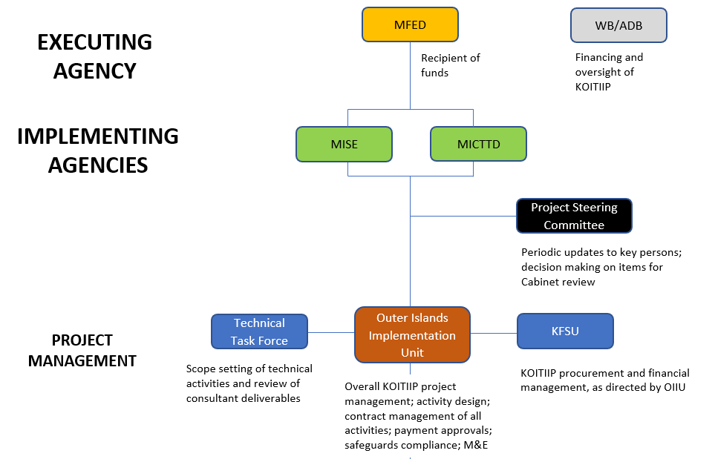
Annex 1: Institutional Structure of KOITIIP demonstrating the role of the OIIU

Annex 2: Map of Kiribati
(1) Details of Kiribati (source: mapsland.com)
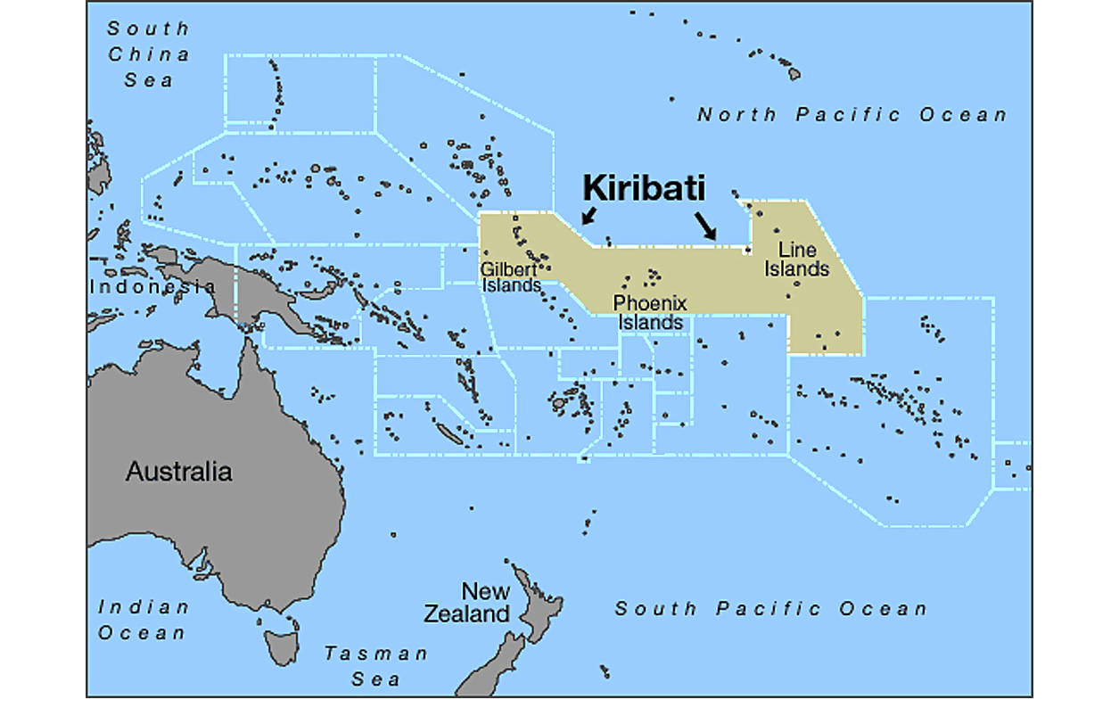

World Bank Open Data, 2016.
Government of Kiribati, Population and Housing Census, 2015
International Labour Organization, Employment and Environmental Sustainability Fact Sheets 2017
Kiribati: Climate Change and Migration. Relationships between household vulnerability, human mobility and climate change. 2016, United Nations, Institute for Environment and Human Safety. https://collections.unu.edu/eserv/UNU:5903/Online_No_20_Kiribati_Report_161207.pdf
Depending on cost, the surveying effort may be extended to cover other outer islands.
This consulting firm, financed through Sub-Components 2.2.c and 2.3.b, will mentor MISE staff throughout all project phases (design, construction, maintenance). The consulting firm will also conduct formal quality assurance audits of all designs financed under Component 2.
Suggested data fields include: Contract No.; Description; Type (Goods/Consulting Services/Works); Company; Signed Date; Intended Completion Date; Contract Amount; Approved Variations/Change Orders; Adjusted Contract Amount; Paid Amount to date; Paid as Percentage of Total Contract Amount; Implementation Progress (%); and, Comments on Progress.

